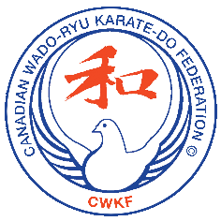
CWKF Grading Registration Form
Grading Date ___________________________
Grading Fees: 9, 8, 7 Kyu $ 30.00
Grading Fees: 6, 5, 4 Kyu $ 35.00
Grading Fees: 3, 2, 1 Kyu $ 40.00

Payment may be made by e-transfer to CWKF.Membership.Fees@gmail.com , Cash or Cheque (payable to “Canadian Wado-Ryu Karate Federation”).
A week before Grading Day you must:
⬜ Have paid your club dues (attempting 8th KYU and up), and OKF.
⬜ Have delivered to an assistant instructor this form fully completed a week prior to grading and requested a CWKF passport/grading record book.
⬜ (8th Kyu and up only) Wear a white karate gi with club patch.
Failure to comply with any of the above may result in the inability to Grade
----------------------------------------------- Detach Here ---------------------------------------------
Name _________________________________________________ Age ______
Please Print
Kyu to be Taken __________ Attempt ________ (1, 2, or 3) Date of Last Grading ______________________
Fee Payment: E-transfer / Cheque / Cash (Circle One) – Amount $____________
Previous Martial Art Experience _______________________________________ (Style, Level, Where, Time, etc.)

